Research Methodology

Unit 1

**Meaning of Research**

* **Research** is *creative* and systematic work undertaken to increase the stock of *knowledge.*
* *So basically, Search of knowledge.*
* It involves the collection, organization and analysis of information to increase understanding of a topic or issue.
* Scientific and systematic search for pertinent information on a specific topic.
* Art of Scientific Investigation.
* A careful investigation or inquiry specially through search for new facts in any branch of knowledge.
* A research project may be an expansion on past work in the field.
* To test the validity of instruments, procedures, or experiments, research may replicate elements of prior projects or the project as a whole.
* Redman and Mory “ Systematic effort to gain new knowledge.”
* Clifford Woody says
  + Defining and redefining problems,
  + formulating hypothesis,
  + collecting,
  + organizing and evaluating data,
  + making deductions and reaching conclusions”

**Objectives of Research**

* To gain new insights into a phenomenon.( studies with this objective are termed as exploratory or formulative research studies)
* To portray accurately the characteristics of a particular situation, person or a group.( studies with this objective are descriptive research)
* To determine the frequency with which something occurs.( diagnostic research).
* To test a hypothesis of a causal relationship between variables( hypothesis testing research)

**Motivation (Why do you want to do Research?)**

* Desire to get a research degree along with its consequential benefits
* Desire to face challenge in solving the unsolved problems
* Desire to get intellectual joy of doing some creative work.
* Service to society
* To get respect

**Types of Research**

Descriptive vs Analytical

Applied vs Fundamental

Quantitative vs Qualitative

Conceptual vs Empirical

1. Descriptive vs. Analytical

* Surveys and fact finding enquiries
* Major purpose of descriptive research is description of the state of affairs as it exists at present (Ex post facto Research in Social Sciences and Business )
* In Analytical research, facts or information already available is used.

Researcher analyzes this info/facts and prepare a critical evaluation.

* Main Characteristic: The researcher has no control over the variables- he can only report what has happened, or what is happening;

e.g.: frequency of shopping, preferences of people

* Methods used for such research: Comparative and correlation.

In analytical research, the researcher has to use facts or information already available and analyze these to make a critical evaluation of the material

2. Applied vs Fundamental

**The research can either be applied (or action) research or fundamental (or basic or pure) research**

Applied vs Fundamental

Aims at finding a solution for an immediate problem facing a society or an industrial business organization.

Market research, design, safety, health, pollution, societal, environmental, industrial, pharmaceutical etc.

Mainly concerned with generalizations and with the formulation of a theory.

e.g. pure mathematics, theoretical physics, generalization of human behavior.

1. Quantitative vs Qualitative

Quantitative

* Based on the measurement of quantity or amount
* Controlled, rather easy to carryout
* Objective and repeatable
* Easy to draw conclusions and decisions

Qualitative

* Concerned with qualitative phenomenon, i.e., involving quality

or kind

Eg. To discover the underlying motives of human behavior;

Attitude or opinion research (how people feel

or think about a particular subject or institution)

difficult job; should seek guidance from

experimental psychologists.

1. Conceptual vs Empirical

Conceptual

* **Related to some abstract idea(s) or theory; generally used by philosophers and thinkers to-develop new concepts or to re-interpret existing ones**

Empirical

* **Relies on experience or observation alone, without due regard for system and theory. It is data-based research, coming up with conclusions which are capable of being verified by observation or experiment.**

* **Characterized by the experimenter’s control over the variable s under** **study and his deliberate manipulation of one of them to study its effects.**
* **Evidence gathered through experiments or empirical studies is today considered to be the most powerful support possible for a given hypothesis**

5. Some Other Types

* Field –Setting Research
* Lab Research depending on the environment
* Simulation Research
* Clinical/Diagnostic Research
* Historical Research etc…..

| **BASIS OF COMPARISON** | **RESEARCH METHOD** | **RESEARCH METHODOLOGY** |
| --- | --- | --- |
| Meaning | Research Method implies the methods employed by the researcher to conduct research. | Research methodology signifies way to efficiently solving research problems. |
| Objective | To discover solution to research problem. | To apply correct procedures so as to determine solutions. |

**Research Process**

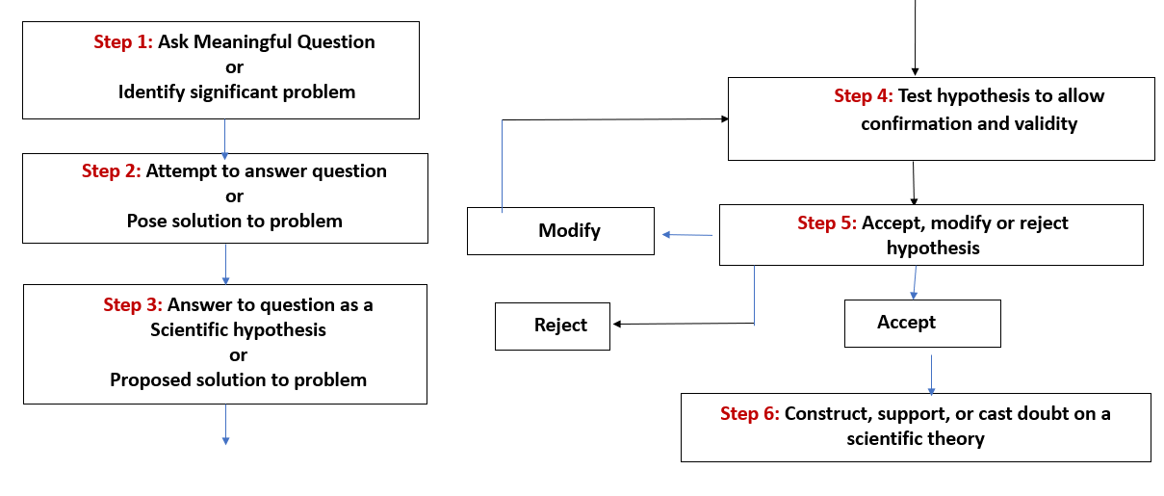

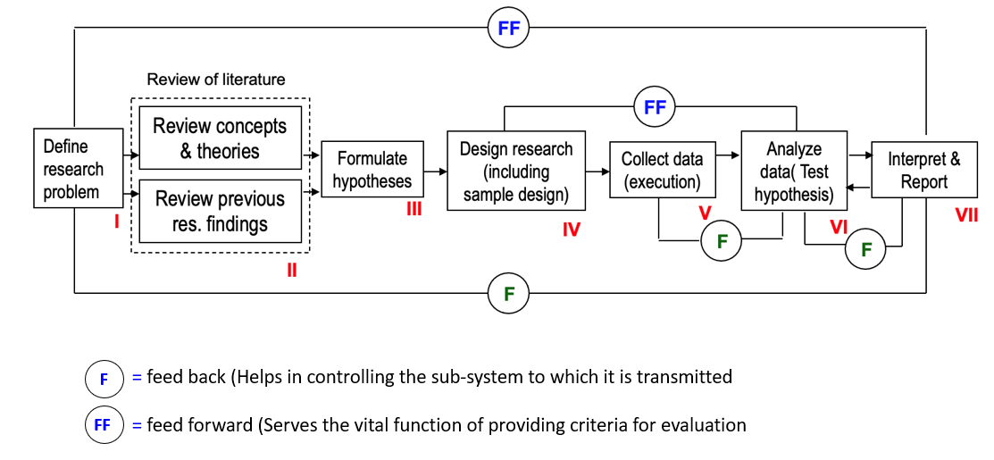

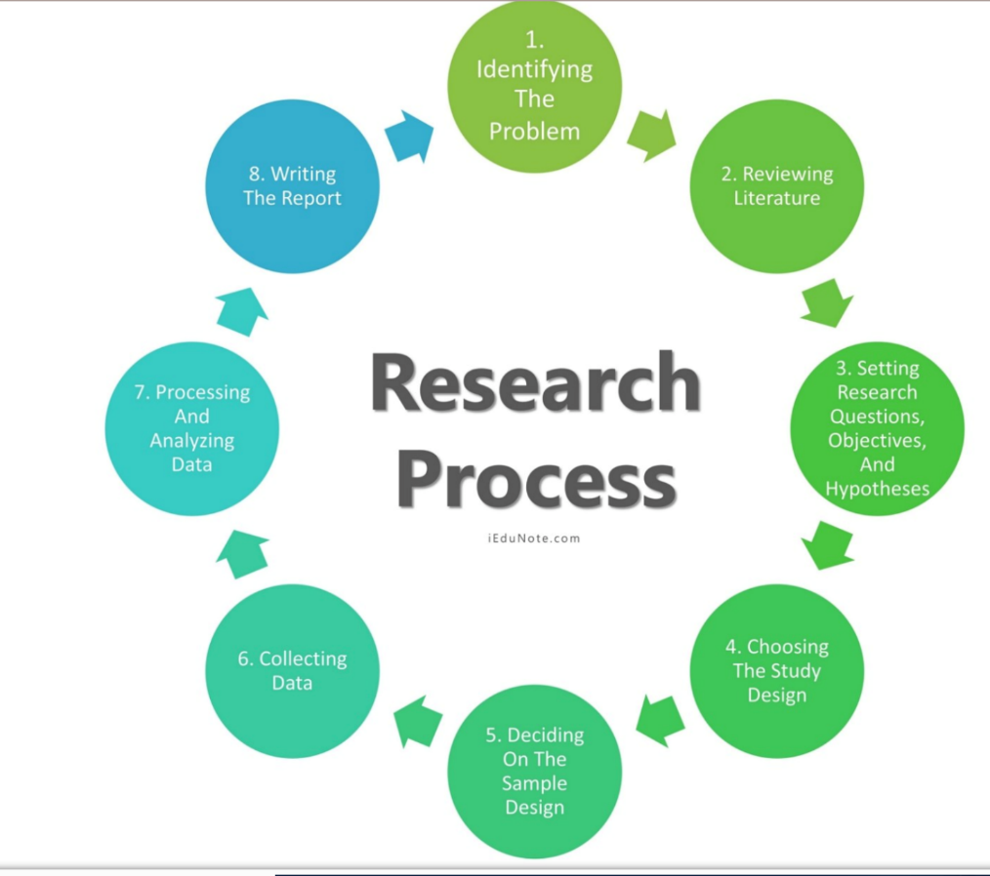

**RESEARCH PROCESS: Series of steps, closely related activities, not mutually exclusive**, **necessary to effectively carry out research.**

1. Formulating the research problem;
2. Extensive literature survey;
3. Developing the hypothesis;
4. Preparing the research design;
5. Determining sample design;
6. Collecting the data;
7. Execution of the project;
8. Analysis of data;
9. Hypothesis testing;

(10) Generalizations and interpretation, and

(11) Preparation of the report or presentation of the results, i.e., format write-up of conclusions reached.

**Research Process**

**1. Formulating the Research Problem:**

**A problem statement is an explanation in research that describes the issue that is in need of study**.

What should be there in a Problem statement?

*-How will your research contribute to the existing knowledge base in your field of study?*

*-How is it significant?*

*-Why does it matter?*

* Think and rethink
* Initially the problem may be stated in a broad general way and then the ambiguities, if any, relating to the problem be resolved.
* The feasibility of a particular solution has to be considered before a working formulation of the problem can be set up.
* Discuss the problem with one’s own colleagues or with those having some expertise in the matter.
* Seek the help from a guide who is usually an experienced person and has several research problems in mind.
* Guide puts forth the problem in general terms and it is up to the researcher to narrow it down and phrase the problem in operational terms.

A problem statement defines the gap between your desired goal and the current state of things. With a problem statement, organizations and individuals are able to describe what’s standing in their way, and come up with viable solutions.

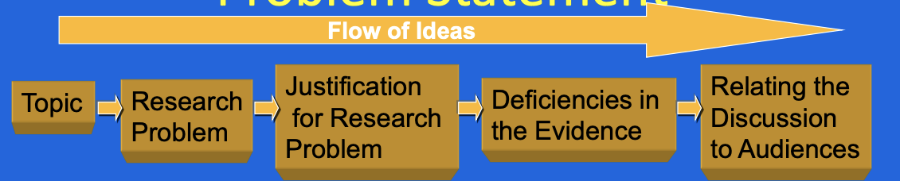 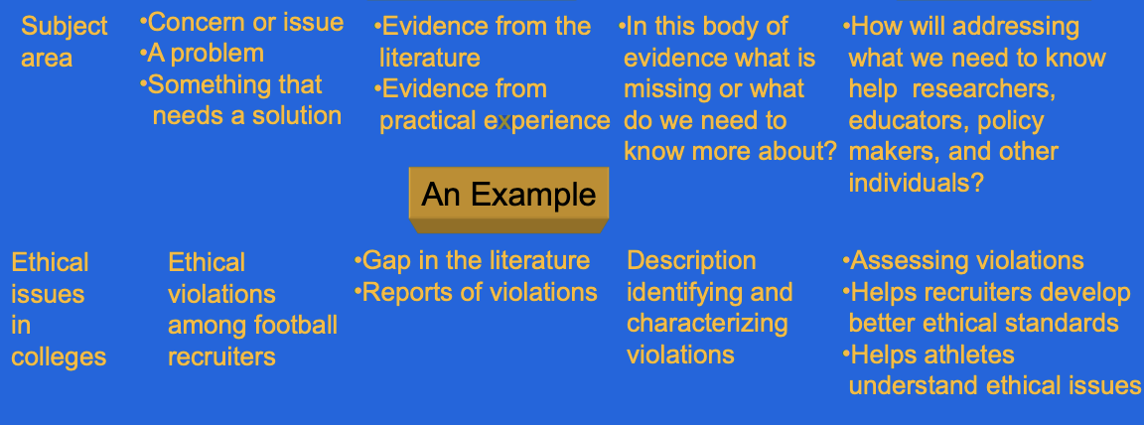

Characteristics of a Research Problem

* Must address the *gap in knowledge*.
* Must contribute positively to the research.
* Must help in further research directions.
* With the data collected, the problem must be understood clearly.
* The problem-solving approach must be ethical

**2. Extensive Literature Survey**

* Academic journals, conference proceedings, government reports, books etc., must be tapped depending on the nature of the problem.
* One source will lead to another.
* The earlier studies, if any, which are similar to the study in hand should be carefully studied.

**3. Development of working Hypothesis**

* State in clear terms the working hypothesis or hypotheses.
* Working hypothesis is tentative assumption made in order to draw out and test its logical or empirical consequences.
* Hypothesis should be very specific and limited to the piece of research in hand because it has to be tested.

How to develop working hypotheses?

* Discussion with colleagues and experts about the problem, its origin and the objectives in seeking a solution
* Examine the data and records, if available, concerning the problem for possible trends, peculiarities and other clues.
* Thorough Review of similar studies in the area or of the studies on similar problems
* Exploratory personal investigation which involves original field interviews **(IF REQUIRED**)on a limited scale with interested parties and individuals with a view to secure greater insight into the practical aspects of the problem.

**4. Research Design**

* Facilitates research to be as efficient as possible yielding maximal information.
* Provides for the collection of relevant evidence with minimal expenditure of effort, time and money
* Experimental and Non-experimental hypothesis testing.

For preparing the research design, consider the following:

* the means of obtaining the information
* the availability and skills of the researcher and his staff
* the time available for research
* the cost factor relating to research
* How the information will be obtained and organized

**5. Determining Sample Design:**

* All the items under consideration in any field of inquiry constitute a ‘universe’ or ‘population’ .
* A sample design is a definite plan determined before any data are actually collected for obtaining a sample from a given population.
* The plan to select 12 of a city’s 200 drugstores in a certain way constitutes a sample design.
* Samples can be either probability samples or non-probability samples.
* **Probability samples** each element has a known probability of being included in the sample
* **Non-probability samples** do not allow the researcher to determine this probability.

Some of the sample designs:

(i) *Deliberate sampling: ( non probability sampling)*

*(ii) Simple random sampling:*

(iii) *Systematic sampling:*

*(iv) Stratified sampling:*

*(v) Quota sampling: ( non probability sampling)*

*(vi) Cluster sampling and area sampling*

*(vii) Multi-stage sampling*

*(viii) Sequential sampling:*

*The sample design to be used must be decided by the researcher taking into consideration the nature of the inquiry and other related factors*.

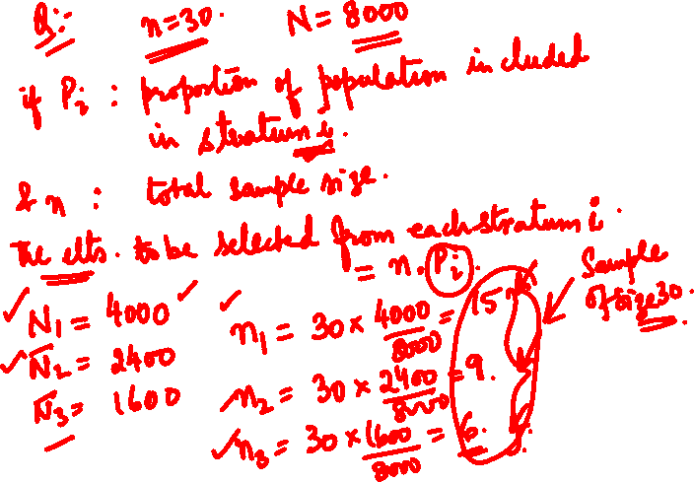

**Cluster Sampling:**

Suppose 15,000 customers.

We want a sample of 450.

Form 100 clusters of size 150 each.

3 clusters can be selected randomly for a sample size of 450.

**Multistage Sampling:**

* Enhanced form of Cluster Sampling.
* Meant for large geographical areas.
* 1st stage of sampling can be large primary units like states, then for 2nd stage districts, 3rd stage towns and so on.
* Multi stage random sampling.

**6. Collecting the Data**

Data can be Primary or Secondary Data

* *By observation*
* *Through personal interview:*
* *Through telephone interviews*
* *Through questionnaires*
* *Through schedules:*

*The researcher should select one of these methods of collecting the data taking into consideration the nature of investigation, objective and scope of the inquiry, financial resources, available time and the desired degree of accuracy.*

**7. Execution of the Project:**

The researcher should see that the project is executed in a systematic manner and in time.

**8. Analysis of Data**

* After the data have been collected, the researcher turns to the task of analysing them.
* The analysis of data requires a number of closely related operations such as establishment of categories, the application of these categories to raw data through coding, tabulation and then drawing statistical inferences.

**9. Hypothesis Testing**

* After analysing the data, the researcher is in a position to test the hypotheses, if any, he had formulated earlier.

Do the facts support the hypotheses or they happen to be contrary?

* Various tests, such as *Chi square test, t-test, F-test,* have been developed by statisticians for the purpose.
* Hypothesis-testing will result in either accepting the hypothesis or rejecting it.

**10. Generalization and Interpretation**

* If a hypothesis is tested and upheld several times, it may be possible for the researcher to arrive at generalisation, i.e., to build a theory.
* If the researcher had no hypothesis to start with, he might seek to explain his findings on the basis of some theory. It is known as *interpretation.*
* The process of interpretation may trigger off new questions which in turn may lead to further researches.

**11. Preparation of the Report or the Thesis**

* The layout of the report should be as follows: (*i*) the preliminary pages; (*ii*) the main text, and (*iii*) the end matter.
* *The main text of the report* should have the following parts:

(a)  *Introduction:*

(b)  *Summary of findings:*

(c)  *Main report:*

(d)  *Conclusion:*

*At the end of the report*, appendices should be enlisted in respect of all technical data. Bibliography, i.e., list of books, journals, reports, etc., consulted, should also be given in the end

**Criteria of a Good Research**

1. The purpose of the research should be clearly defined and common concepts be used.

2. The research procedure used should be described in sufficient detail to permit another researcher to repeat the research for further advancement, keeping the *continuity of what has already been attained*.

3. The procedural design of the research should be carefully planned to yield results that are as objective as possible.

4. The researcher should report with complete frankness, flaws in procedural design and estimate their effects upon the findings.

5. The analysis of data should be sufficiently adequate to reveal its significance and the methods of analysis used should be appropriate. The validity and reliability of the data should be checked carefully.

6. Conclusions should be confined to those justified by the data of the research and limited to those for which the data provide an adequate basis.

7. Greater confidence in research is warranted if the researcher is experienced, has a good reputation in research and is a person of integrity.

**Problems Encountered by Researchers in India**

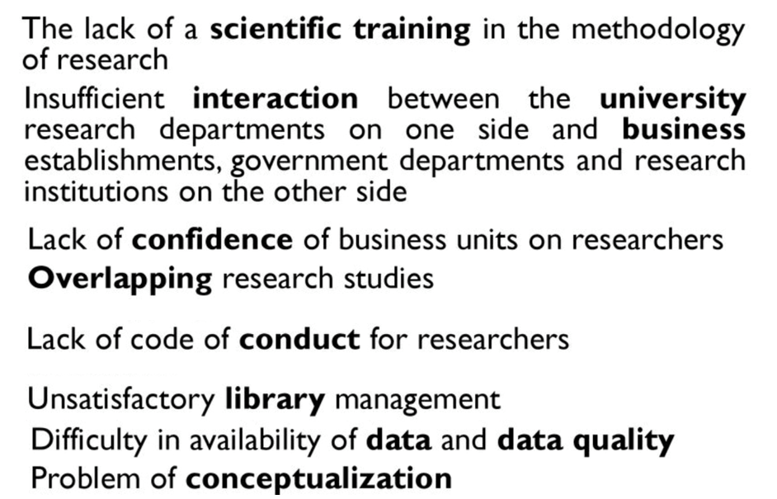

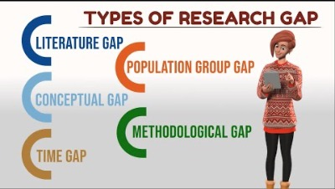

**Literature Review ( A quick Review)**

* A critical analysis of existing research in your field; it highlights both the strengths and weaknesses of existing research
* Allows you to gain a critical understanding of your field
* Opportunity to think about what has been done in your field; opportunity to think about the similarities, patterns, trends and also differences across the existing research
* By identifying strengths and weakness, you will be able to think about what has not/needs to be done in your field
* The gap in the literature is your justification for your research

A literature review is a process as well as an outcome!

* **Literature review as an outcome**: appears in the final draft of your thesis as part of your introduction or as a separate chapter.
* **Literature review as a process**: critical engagement (thinking, reading and writing) with relevant research on your topic. It is a crucial and formative stage of your thesis journey.

**Critical Thinking as a Student**

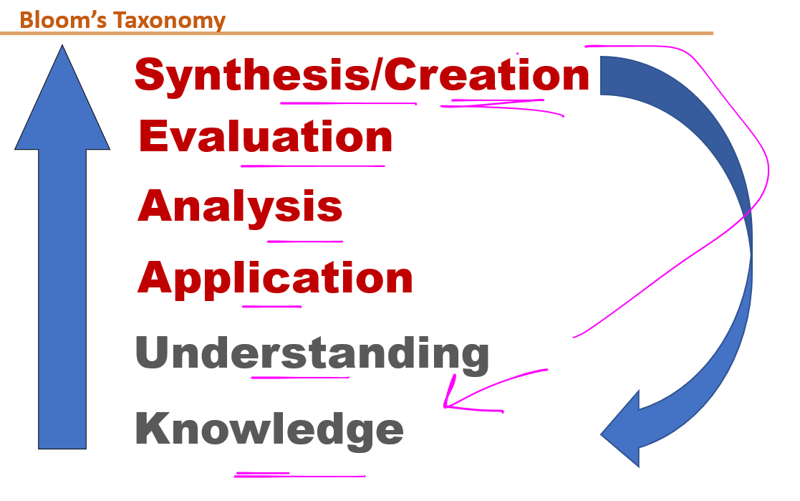

Think about:

* + What were the research aims of the paper/book?
  + Is the research aim achieved? If so, how did they do it?
  + Are there any problems with their methodology?
  + Was it a strong or a weak research model?
  + How will this research help with your own research?
  + What can you take from it?
  + What needs to be avoided?
  + **What are you doing differently**?

**What critical thinking means in terms of Literature Review**

* A cross-sectional study involves looking at data from a population at one specific point in time.
* The participants in this type of study are selected based on particular variables of interest.
* Cross-sectional studies are often used in [developmental psychology](https://www.verywellmind.com/developmental-psychology-4157180), but this method is also used in many other areas, including social science and education.
* Cross-sectional studies are [observational](https://www.verywellmind.com/what-are-observational-studies-2224215) in nature and are known as [descriptive research,](https://www.verywellmind.com/introduction-to-research-methods-2795793)

**Writing a Literature Review**

* Start with an overview
* Decide on organising principles (themes, trends, methodology, chronology, controversies – usually a combination of some of these)
* Use headings for the different sections of the review
* Provide summative signposts of where your argument is leading
* Summarise your review/highlight ‘gap’ in research

**Tips for clear writing:**

* Clear introduction: overview of topic, aim of review and structure
* Clear paragraph structure
* Make sure the subject of your sentence is clear
* Don’t assume knowledge
* Make sure key terminology and difficult ideas are always explained thoroughly (ask your yourself: does it make sense?)
* Be objective and balanced
* Use signposts to orientate the reader

Where appropriate, begin sections and paragraphs with a statement which synthesises or analyses, rather than just describes

Use signposting words to demonstrate how texts relate to each other and also what you think of them

Eg. However, yet, moreover, indeed, similarly etc

**Use of Citation in Literature Review**

* A **citation** is a [reference](https://en.wikipedia.org/wiki/Reference) to a source like an article, book, or video.
* Citations have several important purposes:
  + to uphold intellectual honesty(or avoiding plagiarism ),
  + to attribute prior or unoriginal work and ideas to the correct sources
  + to allow the reader to determine independently whether the referenced material supports the author's argument in the claimed way.

**Importance of Citing Sources**

Citing sources is sometimes tedious and challenging, but it is extremely important for a number of reasons:

1. It makes the paper more credible because it demonstrates that the writer has explored trustworthy sources of information.
2. It demonstrates respect and appreciation for the work of other writers.
3. It allows the reader to follow up on any information presented within the paper by locating the original source.
4. It prevents plagiarism, using someone else's words or ideas without acknowledging their ownership.

**Two types of citations:**

**Integral:** The author’s name appears in the sentence.

Example (author-date system): Lillis (2001) argues that both tutors and students often lack explicit knowledge of the conventions governing the construction of academic texts.

**Non-integral:** The author’s name appears outside sentence.

Example: Both tutors and students often lack explicit knowledge of the conventions governing the construction of academic texts (Lillis, 2001).